**What is Easy Sprite Sheet Copy?**

*Easy Sprite Sheet Copy* allows you to easily copy the Unity settings from one modified sprite sheet into another! This includes settings like the Sprite Mode, Pixels Per Unit, Filter Mode, and (most importantly) the sliced sprites from the Sprite Editor! The process is very similar to the “Component Copy” context menu option that appears when you right click a component in the inspector.

So why would you need something like this? It can be wrapped up as so: Re-Skinning. By using the Re-Skinned script shown in Unite 2014’s “2D Best Practices In Unity” presentation (seen [here](https://www.youtube.com/watch?v=HM17mAmLd7k#t=1605) , 26:45 minutes in), you can easily swap out armor, hair, etc using different sprite sheets, but ONLY as long the sliced sprites have the same names! *Easy Sprite Sheet Copy* allows you to quickly perform this type of copy/paste of data!

**How to use Easy Sprite Sheet Copy**

These steps assume that you have imported the asset into your project.   
Note that the “*EasySpriteSheetCopy.cs*” file must be in a folder called “Editor” for the script to work.

1. Modify the sprite sheet you would like to copy settings from.
2. With your sprite sheet selected, click the Gear icon in the Inspector window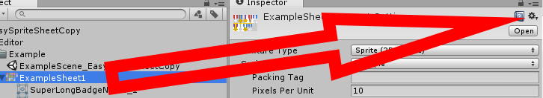
3. Choose the level of “Copy” that you want. In this example, we will choose the option labeled: **“*Copy All Sprite Sheet Settings”***
4. In the Project tab/window, select the sprite sheet you would like to paste settings to
5. With the new sprite sheet selected, click the Gear icon in the inspector window, and choose the ***“Paste Copied Settings”*** option
6. All done!

**Options**

* **Copy All Sprite Sheet Settings** - Copies all sprite settings, including platform specific overrides
* **Copy All Except Overrides** – Copies all sprite settings except for platform specific overrides
* **Copy Only Overrides -** Only copies platform specific overrides
* **Paste Copied Settings -** Pastes the previously copied sprite sheet settings
* **Reset Overrides -** Clears platform specific overrides while leaving general sprite settings alone
* **Reset Sprite Settings (Exclude Overrides) -** Clears all sprite settings while leaving overrides alone

**Support**

Guidez – support@pausebreakstudios.com